**Wrong Ref: Load Number Removing Tool (SO)**

**Description:**

This tool removes the wrong Ref: Load Number that attaches to a SO. Whenever an order gets re-planned, the historical load will be removed while a new load is attached. However, the reference remains on the SO. The program automatically identifies attached load number, compares it with Ref: Load Number, and then, remove the wrong ones.

**Standard Operating Procedure:**

1. Download the zip file from below link:

<https://drive.google.com/open?id=1bXETjEtxT_cFc4rq3i6J1bJEYKYdn3S8>

1. Save the zip file in a preferred folder, extract it by right-clicking and selecting ‘Extract All..’.

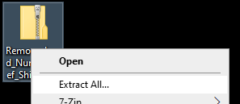

1. Click ‘Extract’ without changing anything.

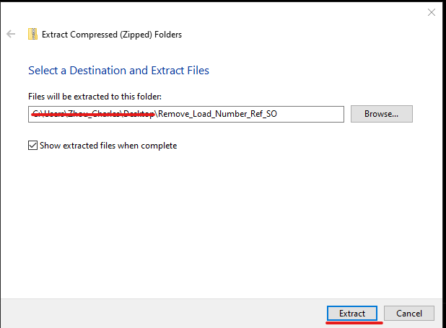

1. Open the folder extracted, there are 5 files.

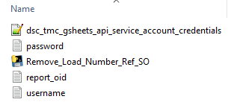

1. Open username.txt and password.txt using Notepad, save your TMS username and password to each file respectively (DO NOT include any space). DO NOT make any change to report_oid.txt file. Report to Cheryl Tavolier or Charles Zhou if there is any issue.
2. Double-click ‘Remove_Load_Number_Ref_SO’ to launch the program. It runs automatically. If it closes itself within 10 seconds, it means there is bug, and it runs unsuccessfully. Please report the issue.
3. If the program run successfully, it will show a screen like below:

